Problem 2 – Lover of 3
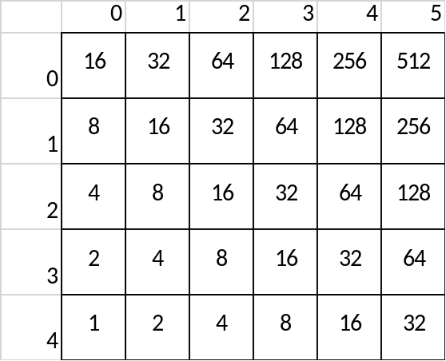
Pesho is a lover of 2. He loves everything that is a power of 2. He loves 2 so much, he created his own game with twos. Yet, Pesho is not a bright one, so he cannot calculate the result in his own game. The game is as follows:
The game has a rectangular field. The field is filled with numbers that are power of 2, as follows:
- The bottom left corner holds the value 1
- The next cell above holds value of 2, the next cell above holds of 4, etc…
- The second cell the bottom row holds a value of 2, the cell next to it holds a value of 4
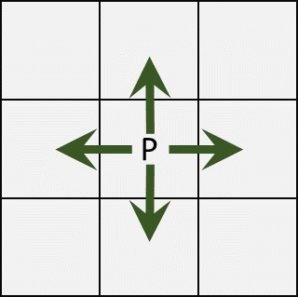
You have a pawn on the field. The pawn can only move to the cells that directly above, below it or right/left of it. We have four directions UP, DOWN, LEFT, RIGHT.
Given that initially the pawn starts at the bottom left corner and a list of cells that the pawn must reach calculate the sum of the cells that the pawn has to go through.
The value of each cell is calculated only once, i.e. if the pawn visits the same cell more than once, its value is added to the result only the first time (the value is collected).
The top row is at position 0, the bottommost row is at position ROWS – 1.
The pawn goes from one cell to the other, following the rules:
- First go to the same row
- Second go to the same column
Example:
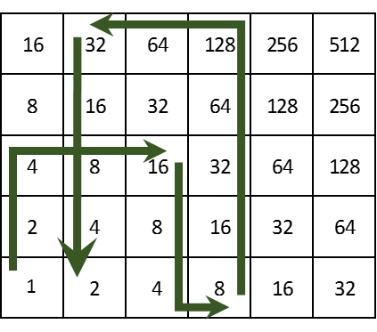
The pawn collects values: 1, 2, 4, 8, 16, 8, 4, 8, 16, 32, 64, 128, 64, 32, 16, 4 and 2. Their sum is 409.
Help Pesho in the calculation of the result!

Input
The input data is given at the standard input, i.e. the console
On the first and the second lines you will find the dimensions of the field R and C
On the third line you will find the number N, the number of directions and moves
On the fourth line you will find the CODEs, decimal numbers that represents the positions from the path of the pawn. They will be separated by a single space. The position is encoded as follows:
- A coefficient is calculated, COEFF = MAX(R, C)
- ROW = CODE / COEF
- COL = COEF % COEF
The input will be valid, in the specified format, within the constraints given below. There is no need to check the input data explicitly.

Output
Print the sum of cells contained in the path of pawn

Constraints
- R will always be between 1 and 100
- C will always be between 1 and 75
- N will always be between 1 and 1000
- Allowed working time for your program: 0.1 seconds.
- Allowed memory: 16 MB.

Example
Input | Output | Explanation
5  6  4  14 27 1 25 | 409 | In the example

